PART 4: Created IAM Group

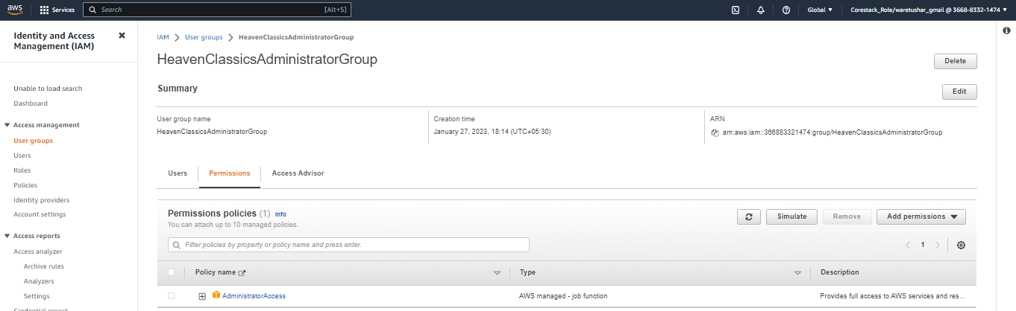

Created User:

